Table of Contents

**Use case and Class Diagrams1**

Use Case Diagram3

Class Diagram3

**Functional and Integration Testing**4

Functional Testing: 4

Integration Testing6

**Test Cases In Detail**9

**Testers Involved**

|  |  |  |  |  |
| --- | --- | --- | --- | --- |
| **Tested By** | **Tested**  **Date** | **Approved**  **By** | **Approval**  **Date** | **Tasks** |
| **Bharadwaj** | ***04-15-2015*** | ***Arpan*** | ***04-17-2015*** | **Functional Tests** |
| **Bharadwaj** | ***04-15-2015*** | ***Arpan*** | ***04-17-2015*** | **IntegrationTests** |

1. USE CASE and CLASS DIAGRAMS
   1. Use Case Diagram

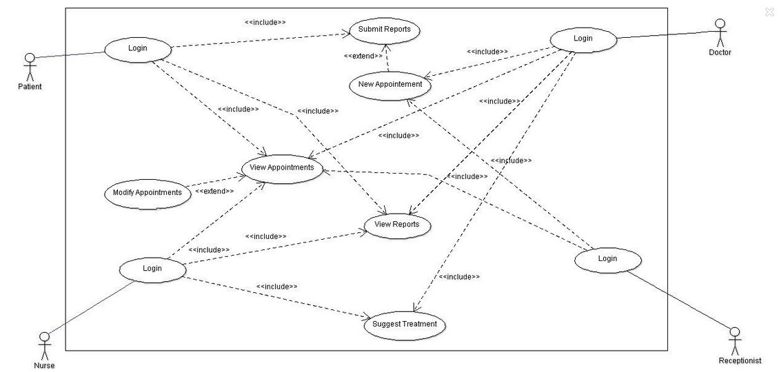

* 1. **Class Diagram**

1. **Functional and Integration Testing**
   1. **Functional Testing:**

Functional tests were performed on the UI and through console to verify the functionalities. The Functionalities were verified on java 8.0.

Functional test Cases

|  |  |  |  |
| --- | --- | --- | --- |
| Test Scenario | Test case ID | Test Case | Result |
| Log in the Application | TC_1 | Verify that user can Login As Patient | Able to Login as Patient |
| TC_2 | Verify that user can Login As Doctor | Able to Login as Doctor |
| TC_3 | Verify that user can Login As Receptionist | Able to Login as Receptionist |
| TC_4 | Verify that user can Login As Nurse | Able to Login as Nurse |
| View Appointments | TC_5 | Verify Patient can see his Appointments | Able to see appointments |
| in decreasing order |
| TC_6 | Verify Doctor can see patients Appointments | Able to see appointments |
| in decreasing order |
| TC_7 | Verify Patient cannot see others Appointments | Unable to see appointments |
| Make Appointments | TC_8 | Verify Patients can make Appointments | Cannot make Appointments |
| TC_9 | Verify Receptionist can make appointments | Can make appointments |
| View Reports | TC_10 | Verify Doctor can see patients Reports | Able to see patients reports |
| TC_11 | Verify patients can see only his reports | Able to see doctor reports |
| Submit Reports | TC_12 | Verify only Patient can submit reports | able to submit patients reports |
| TC_13 | Verify Doctor doesn’t have the option of submitting Report | Doctor cannot submit report |
| Suggest a treatment | TC_15 | Verify Doctor can suggest a treatment | Able to suggest a treatment |
| TC_16 | Verify Receptionist can suggest a treatment | Able to suggest a treatment |
| TC_17 | Verify Nurse can suggest a treatment | Able to suggest a treatment |
| Modify Appointment | TC_18 | Verify User can Modify the Appointment | Able to modify |
| Login | TC_19 | User is logged into a single role | Able to Login |

**Test Risks:**

* Enough time was not available for testing.
* Exhaustive Testing is not possible.
* Prioritized Testing has been given More Preference.

Test Results

|  |  |  |  |
| --- | --- | --- | --- |
| Defect ID | Defect | Status | Test Case |
| Def_1 | Appointments couldn’t be viewed properly by Doctor | Closed | TC_6 |
| Def_2 | Patient is prompted to make appointments though fails with error | Closed | TC_8 |
| Def_3[1] | Modify Appointment is not available | Resolved | TC_18 |

[1] The Functionality has been implemented and combined with View Appointments

III. Functional Testing Metrics

* 1. **Integration Testing**

Integration Tests were performed on the Application having Java 8.0

**Integration Test Cases**

|  |  |  |  |
| --- | --- | --- | --- |
| Test Case ID | Test Case | Test Steps | Result |
| TC_1 | Verify Functionality of receptionist | Login as a Receptionist | Pass |
| Create an Appointment for Patient | Pass |
| TC_2 | Verify Functionality of patient | Login as a Patient | Pass |
| View the appointment Created | Pass |
| Submit a Report | Pass |
| View the submitted Report | Pass |
| TC_3 | Verify Functionality of Doctor | Login as Doctor | Pass |
| View my Appointments | Pass |
| view Reports of patient | Pass |
| Make an appointment | Pass |
| Suggest a note | Pass |
| TC_4 | Verify Functionality of Nurse | Login as Nurse | Pass |
| View my Appointments | Pass |
| view Reports of patients | Pass |
| Suggest a note | Pass |

Test Results

|  |  |  |  |
| --- | --- | --- | --- |
| Defect ID | Defect | Status | Test Case |
| Def_1 | Report Created was not visible through view reports | Closed | TC_2 |
| Def_2 | Submitted Reports was not Visible for Doctor | Closed | TC_3 |

III. Integration Testing Metrics

1. **Test Cases In Detail**

**Functionality:** Login with correct inputs

|  |  |  |  |  |
| --- | --- | --- | --- | --- |
| **Test Case** | **Inputs** | | | **Expected Output** |
|  | **Role** | **Username and Password** | **No. of Attempts** |  |
| Verify Can Login with Correct Role | Correct Role | --- | ---- | Enter credentials |
|  | Correct Credentials | ---- | Logged in Successfully |

**Functionality:** Login with incorrect inputs

|  |  |  |  |
| --- | --- | --- | --- |
| **Test Case** | **Inputs** | | **Expected Output** |
|  | **Username and Password** | **No. of Attempts** |  |
| Login with Improper inputs | **----** | ---- | Enter credentials |
| Incorrect Credentials | Less than 3 | Incorrect credentials Attempt No. |
| Login with Improper inputs more than 3 times | --- | --- | Enter credentials |
| Incorrect Credentials | More than 3 | Sorry you are not allowed more than 3 attempts at a time. |

**Functionality:** View Reports with Appropriate Role

|  |  |  |  |
| --- | --- | --- | --- |
| **Test Case** | **Input** | | **Output** |
|  | Role | Patient ID |  |
| Patient can view only his reports | Patient | --- | All his reports are shown |
| Doctor can view only his patients reports | Doctor | Correct | See Reports of his patients |
| Nurse can view all patients reports | Doctor | Correct | See Reports of the all patients |
| Receptionist can view all patients report | Correct | See Reports of the Patient selected | See Reports of the all patients |

**Functionality:** Submit a Symptom Report

|  |  |  |
| --- | --- | --- |
| **Test Case** | **Input** | **Output** |
|  | Role |  |
| Patient can submit a report | Patient | Only patient can submit the report |
| Others cannot submit the report | Doctor, Nurse ,Receptionist | They do not have the option to submit the report |

**Functionality:** View Appointment with Appropriate Role

|  |  |  |
| --- | --- | --- |
| **Test Case** | **Input** | **Output** |
|  | Role |  |
| View Appointments | Doctor, Nurse, Receptionist | Able to see all appointments on homepage with patient name, date time and description |
| View Appointments | Patient | Able to see all appointments on homepage with Doctor ,date time and description |

**Functionality:** Create an Appointment

|  |  |  |  |
| --- | --- | --- | --- |
| **Test Case** | **Input** | | **Output** |
|  | Role | Patient ID |  |
| Make an Appointment | Patient | --- | Cannot make appointment. |
| Make an Appointment | Doctor, Nurse, Receptionist | Select an patient ID | A link is shown in login page for Making Appointment |

**Functionality:** Modify an Appointment

|  |  |  |  |  |
| --- | --- | --- | --- | --- |
| **Test Case** | **Input** | |  | **Output** |
|  | Role | Option | Appointment ID |  |
| 14(Path 8) | Patient | Modify | Select an Appointment ID | A link is shown in Home page for Modifying Appointment |
| 15(Path 8) | Employee | Modify | Select an Appointment ID | A link is shown in Home page for Modifying Appointment |

**Functionality:** Suggest a Care

|  |  |  |  |  |
| --- | --- | --- | --- | --- |
| **Test Case** | **Input** | | | **Output** |
|  | Role | Symptom Report ID | Recommend an Appointment |  |
| Suggest a Treatment | Patient | --- | -- | The functionality shouldn’t be available to patient |
| Suggest a Treatment for Report | Nurse, Doctor,  Receptionist | Click on Suggest a care | -- | A Pop Up appears for Suggesting an Appointment. |